Cereal Box Book Report Project

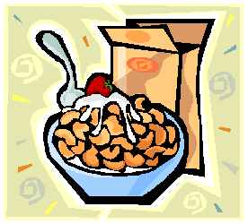Students will decorate a real cereal box with illustrations and information related to the book they read using the directions below. I expect a lot of time, effort, and hard work to be put into these
reports, not for them to be completed sloppily in one night. I also will expect all directions to be followed,
so a copy of the rubric that will be used to grade the book report has been attached.

FRONT OF BOX: Use a piece of white or light colored paper to cover the front of your cereal box. (You will probably want to create the cover before gluing it on your box.) Include the name of the cereal and a picture. Invent a name for the cereal that is related to the title of the book and sounds like a cereal. Do not use the exact title of the book. You may want to look at the attached page of real cereal boxes to get some ideas. Choose a shape for the cereal as well as colors and ingredients that all relate to the book. For example, for Harry Potter and the Sorcerer's Stone, you might invent a cereal called Wizard Wands, a toasted oat cereal in the shape of miniature lightning bolts.

RIGHT SIDE: Make a list of ingredients that includes the story elements CHARACTERS and SETTING. Under the heading "Ingredients," list the main character and write a sentence about each one. Then describe the setting. You can use the template on the website or cover the side with white/light colored paper and do this your own way.

LEFT SIDE: Pick 4 words you are not familiar with. Find the part of speech, definition, and use the word in a sentence. You can use the template on the website or cover the side with white/light colored paper and do this your own way.

BACK OF BOX: Write a summary that describes the book. Try to use words that will “grab” readers’ attention and make them want to buy your cereal. You can use the template on the website or cover the side with white/light colored paper and do this your own way. Your summary must be three to five sentences.
Design a game that is based on the book. It can be a puzzle, a word search, a word scramble, a maze, a crossword puzzle, a hidden pictures illustration, or any other fun activity that might be found on the back of a cereal box. Make sure it includes information from the book.

TOP OF BOX: Include the title, author, number of pages, and number of stars you would give this book if you were a book critic. Also, include your name. The maximum number of stars would be 5. Use the template on the attached sheet.

PRIZE: Cereal boxes often include a prize. Your prize must be something related to the topic of your book. You can even include a picture of the prize on the front of your box to let the reader know what is inside the box.

Your Cereal Box Book Report IS DUE: Thursday, September 28, 2017

All the templates for this cereal box book report will be available to download from the class website. This will be helpful for students who want to write rough drafts for the sides of their boxes before doing the final copies. Also, if students mess up or want to redo any section of the box, they can just print new copies from the web site.
Cereal Box Book Report Templates

Back of box: Cut out this box and place in on the back side of your cereal box.
Write a summary that describes the main problem and how the problem was solved. Try to use words that will “grab” the readers’ attention and make them want to buy your cereal.

Summary of Book:

Top of Box: Cut out this box and place on the top of your cereal box.

Title of Book:

Author:
# of Pages:

Rating:
Right Side of Box
Cut out this box and place on the right side of your cereal box.

Characters:
List the main characters and write a sentence about each one. For example, if you were using
the story “Charlie and the Chocolate Factory,” you might include the following characters:

Charlie Bucket: He is a poor boy who finds the last golden ticket and wins a trip to Willy Wonka’s Chocolate Factory.

Willy Wonka: He is the lively owner of the chocolate factory who allows six children and a member of their family to spend a day at his magical factory.

Setting:
Use complete sentences to tell where the story takes place. You may find that there is more than one setting in the story. For example, if you were using the story “Charlie and the Chocolate Factory,” you might write:

The beginning of the story takes place in Charlie Bucket’s very small house that he shares with his large family. Once Charlie finds the golden ticket and wins the contest, the rest of the story takes place in Willy Wonka’s amazing chocolate factory.

INGREDIENTS

CHARACTERS:

SETTING:
Glossary
Word #1:_________________________
Part of Speech:_____________________
Definition:__________________________________________________________________________________________
Sentence:___________________________________________________________________________________________

Word #2:_________________________
Part of Speech:_____________________
Definition:__________________________________________________________________________________________
Sentence:___________________________________________________________________________________________

Word #3:_________________________
Part of Speech:_____________________
Definition:__________________________________________________________________________________________
Sentence:___________________________________________________________________________________________

Word #4:_________________________
Part of Speech:_____________________
Definition:__________________________________________________________________________________________
Sentence:___________________________________________________________________________________________

Left Side of Box

Word #1:
GLOSSARY
Cut out this box and place on the left
side of your cereal box.

Glossary
Choose at least four important words from your book and write them down. Include the correct spelling, part of speech, definition, and
a sentence using the word. See example below:

Word #1: tragic
Part of Speech: adjective
Definition: very sad, dreadful, unfortunate Sentence: The death of the main character’s pet toad was tragic.

Part of Speech: _ Definition:
_ Sentence:
_

_ Word #2
Part of Speech: _ Definition:
_ Sentence:
_

Word #3

Part of Speech: _ Definition:
_ Sentence:
_

Word #4 _ Part of Speech: _ Definition:
_ Sentence:
_

_

Word #5 _ Part of Speech: _ Definition:
_ Sentence:
_

_
Cereal Box Book Report Project Rubric

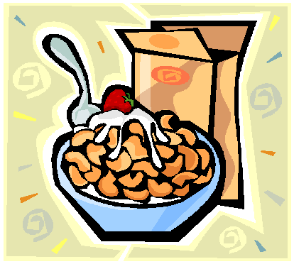Name:

 | Points  Earned | Points  Possible
Score on AR test. |  | 10
Cereal Box is neat, colorful, and attractive. |  | 15
The front and top of the box is complete and thoughtfully done. The top includes the title of the book, the author’s name, and your name. The front includes the name of the cereal  (related to the book) and an original illustration. |  | 15
The back of the box is complete and thoughtfully done. |  | 20
The left side of the box is complete and accurate. |  | 15
The right side of the box is complete and accurate. |  | 15
Spelling, punctuation, and grammar are correct. |  | 10
Total |  | 100

