Football Frenzy Project Suggested Timeline

Project Due February 16, 2017

*We will not be checking the project on these dates. This is just a guideline to keeps students on track to complete their project in a timely manner.*

_____ Part 1: Football Field Diagram

January 18th – 24th

_____ Part 2: Persuasive Paragraph

January 25th – 31st

_____ Part 3: Week 17 Score Line-Up

February 1st – 7th

_____ Part 4: Football Word Problems

February 8th – 16th

C:\Documents and Settings\nelsoml1\Local Settings\Temporary Internet Files\Content.IE5\Q9J7HUFN\MC900019688[1].wmf

C:\Documents and Settings\nelsoml1\Local Settings\Temporary Internet Files\Content.IE5\ME8BNZQ9\MC900412532[1].wmf Football Frenzy Project

**Due February 16, 2017**

**Project Overview**

Your next project will consist of four separate parts: creating a field diagram, collecting scores and finding factors, writing a persuasive paragraph, and writing and solving football themed word problems.

**Part 1: Field Diagram**

Directions: Use the graph paper included to create your own football field. Your field diagram must have the following sections:

**_____ Playing field**

**_____ Home team seating**

**_____ Away team seating**

**_____ Home team goal post**

**_____ Away team goal post**

**_____ Concession stand**

Each section must be labeled with the name of the section and array dimensions. You must also find the product (multiply) of each of the dimensions. (See example on website) Your diagram may be hand-drawn or created on a computer.

**Part 2: Persuasive Paragraph**

Directions: Choose your favorite team and write a persuasive paragraph. Your paragraph must have a thesis statement, three reasons, one piece of evidence to support each reason, and a concluding statement.

**Part 3: Week 17 Line-Up Sheet** (Games played on 1/1/17)

Directions: Use the Week 17 Line-Up Sheet included to collect the data from the games that week. Then you must find **all** the factors of each of the scores and record them on the sheet. Finally, choose your favorite game from the Week 17 Line-Up. List the first 10 multiples of the winning team’s score.

**Part 4: Football Themed Word Problems**

Directions: Create four different football themed word problems with the following operations:

**_____ 3-digit addition**

**_____ 3-digit subtraction**

**_____ 3-digit by 1-digit multiplication**

**_____ 4-digit by 1-digit multiplication**

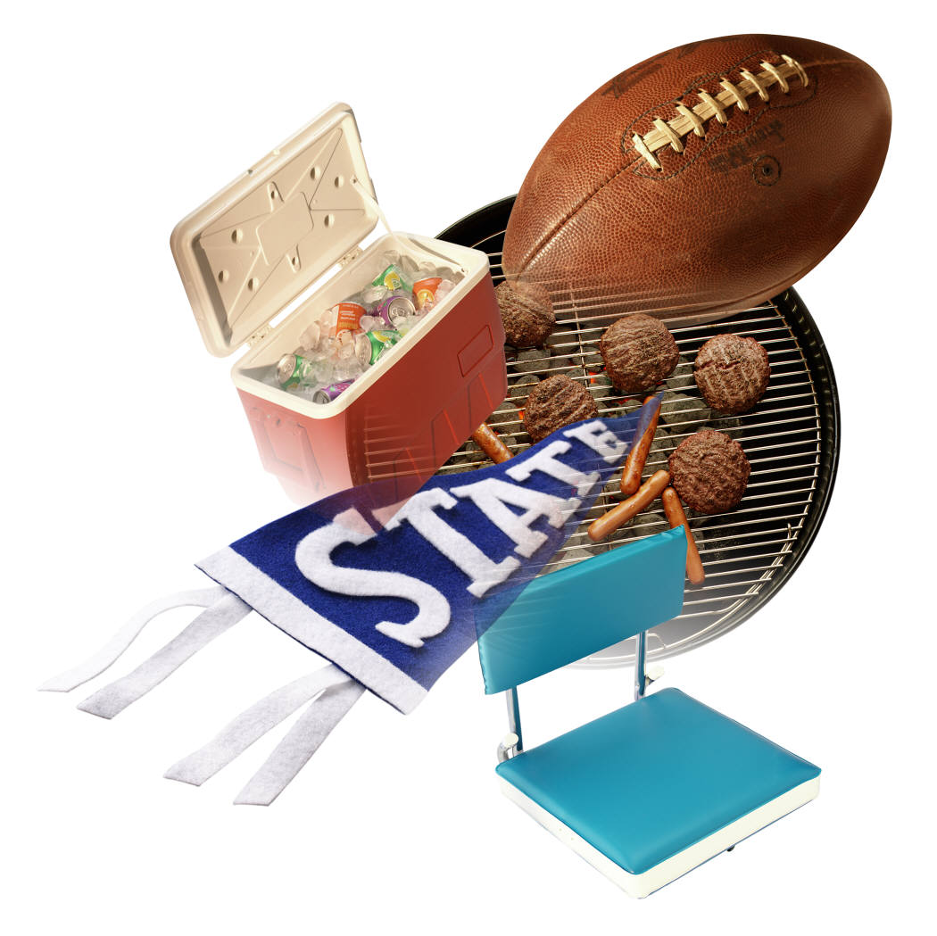Each word problem should include the number sentence that corresponds with the problem and the answer. (See examples on the website)

|  |  |  |  |  |  |  |  |  |  |  |  |  |  |  |  |  |  |  |  |  |  |  |  |  |
| --- | --- | --- | --- | --- | --- | --- | --- | --- | --- | --- | --- | --- | --- | --- | --- | --- | --- | --- | --- | --- | --- | --- | --- | --- |
|  |  |  |  |  |  |  |  |  |  |  |  |  |  |  |  |  |  |  |  |  |  |  |  |  |
|  |  |  |  |  |  |  |  |  |  |  |  |  |  |  |  |  |  |  |  |  |  |  |  |  |
|  |  |  |  |  |  |  |  |  |  |  |  |  |  |  |  |  |  |  |  |  |  |  |  |  |
|  |  |  |  |  |  |  |  |  |  |  |  |  |  |  |  |  |  |  |  |  |  |  |  |  |
|  |  |  |  |  |  |  |  |  |  |  |  |  |  |  |  |  |  |  |  |  |  |  |  |  |
|  |  |  |  |  |  |  |  |  |  |  |  |  |  |  |  |  |  |  |  |  |  |  |  |  |
|  |  |  |  |  |  |  |  |  |  |  |  |  |  |  |  |  |  |  |  |  |  |  |  |  |
|  |  |  |  |  |  |  |  |  |  |  |  |  |  |  |  |  |  |  |  |  |  |  |  |  |
|  |  |  |  |  |  |  |  |  |  |  |  |  |  |  |  |  |  |  |  |  |  |  |  |  |
|  |  |  |  |  |  |  |  |  |  |  |  |  |  |  |  |  |  |  |  |  |  |  |  |  |
|  |  |  |  |  |  |  |  |  |  |  |  |  |  |  |  |  |  |  |  |  |  |  |  |  |
|  |  |  |  |  |  |  |  |  |  |  |  |  |  |  |  |  |  |  |  |  |  |  |  |  |
|  |  |  |  |  |  |  |  |  |  |  |  |  |  |  |  |  |  |  |  |  |  |  |  |  |
|  |  |  |  |  |  |  |  |  |  |  |  |  |  |  |  |  |  |  |  |  |  |  |  |  |
|  |  |  |  |  |  |  |  |  |  |  |  |  |  |  |  |  |  |  |  |  |  |  |  |  |
|  |  |  |  |  |  |  |  |  |  |  |  |  |  |  |  |  |  |  |  |  |  |  |  |  |
|  |  |  |  |  |  |  |  |  |  |  |  |  |  |  |  |  |  |  |  |  |  |  |  |  |
|  |  |  |  |  |  |  |  |  |  |  |  |  |  |  |  |  |  |  |  |  |  |  |  |  |
|  |  |  |  |  |  |  |  |  |  |  |  |  |  |  |  |  |  |  |  |  |  |  |  |  |
|  |  |  |  |  |  |  |  |  |  |  |  |  |  |  |  |  |  |  |  |  |  |  |  |  |
|  |  |  |  |  |  |  |  |  |  |  |  |  |  |  |  |  |  |  |  |  |  |  |  |  |
|  |  |  |  |  |  |  |  |  |  |  |  |  |  |  |  |  |  |  |  |  |  |  |  |  |
|  |  |  |  |  |  |  |  |  |  |  |  |  |  |  |  |  |  |  |  |  |  |  |  |  |
|  |  |  |  |  |  |  |  |  |  |  |  |  |  |  |  |  |  |  |  |  |  |  |  |  |
|  |  |  |  |  |  |  |  |  |  |  |  |  |  |  |  |  |  |  |  |  |  |  |  |  |
|  |  |  |  |  |  |  |  |  |  |  |  |  |  |  |  |  |  |  |  |  |  |  |  |  |
|  |  |  |  |  |  |  |  |  |  |  |  |  |  |  |  |  |  |  |  |  |  |  |  |  |
|  |  |  |  |  |  |  |  |  |  |  |  |  |  |  |  |  |  |  |  |  |  |  |  |  |
|  |  |  |  |  |  |  |  |  |  |  |  |  |  |  |  |  |  |  |  |  |  |  |  |  |
|  |  |  |  |  |  |  |  |  |  |  |  |  |  |  |  |  |  |  |  |  |  |  |  |  |
|  |  |  |  |  |  |  |  |  |  |  |  |  |  |  |  |  |  |  |  |  |  |  |  |  |
|  |  |  |  |  |  |  |  |  |  |  |  |  |  |  |  |  |  |  |  |  |  |  |  |  |
|  |  |  |  |  |  |  |  |  |  |  |  |  |  |  |  |  |  |  |  |  |  |  |  |  |
|  |  |  |  |  |  |  |  |  |  |  |  |  |  |  |  |  |  |  |  |  |  |  |  |  |
|  |  |  |  |  |  |  |  |  |  |  |  |  |  |  |  |  |  |  |  |  |  |  |  |  |
|  |  |  |  |  |  |  |  |  |  |  |  |  |  |  |  |  |  |  |  |  |  |  |  |  |
|  |  |  |  |  |  |  |  |  |  |  |  |  |  |  |  |  |  |  |  |  |  |  |  |  |

**Week 17 Score Line-Up Sheet**

|  |  |  |  |  |
| --- | --- | --- | --- | --- |
|  | **Team** | **Scores** | **Team 1: Score Factors** | **Team 2: Score Factors** |
| **Team 1** | **Baltimore Ravens** |  |  |  |
| **Team 2** | **Cincinnati Bengals** |  |
| **Team 1** | **Houston Texans** |  |  |  |
| **Team 2** | **Tennessee Titans** |  |
| **Team 1** | **Carolina Panthers** |  |  |  |
| **Team 2** | **Tampa Bay Bucaneers** |  |
| **Team 1** | **Cleveland Browns** |  |  |  |
| **Team 2** | **Pittsburgh Steelers** |  |
| **Team 1** | **Dallas Cowboys** |  |  |  |
| **Team 2** | **Philadelphia Eagles** |  |
| **Team 1** | **Buffalo Bills** |  |  |  |
| **Team 2** | **New York Jets** |  |
| **Team 1** | **Chicago Bears** |  |  |  |
| **Team 2** | **Minnesota Vikings** |  |
| **Team 1** | **Jacksonville Jaguars** |  |  |  |
| **Team 2** | **Indianapolis Colts** |  |
| **Team 1** | **New England Patriots** |  |  |  |
| **Team 2** | **Miami Dolphins** |  |
| **Team 1** | **Kansas City Chiefs** |  |  |  |
| **Team 2** | **San Diego Chargers** |  |
| **Team 1** | **Arizona Cardinals** |  |  |  |
| **Team 2** | **Los Angeles Rams** |  |
| **Team 1** | **Oakland Raiders** |  |  |  |
| **Team 2** | **Denver Broncos** |  |
| **Team 1** | **New York Giants** |  |  |  |
| **Team 2** | **Washington Redskins** |  |
| **Team 1** | **Seattle Seahawks** |  |  |  |
| **Team 2** | **San Francisco 49ers** |  |
| **Team 1** | **New Orleans Saints** |  |  |  |
| **Team 2** | **Atlanta Falcons** |  |
| **Team 1** | **Green Bay Packers** |  |  |  |
| **Team 2** | **Detroit Lions** |  |

**Score Multiples**

**(skip count by the score of the winning team)**

**Choose your favorite game from the Week 17 Line-Up. List the first 10 multiples of the winning team’s score.**

Winning Team: _________________________________________________ Score: _____________

Multiples: ____________, ____________, ____________, ___________, ____________,

____________, ____________, ____________, ____________, ____________

**Part 1: Field Diagram Rubric**

|  |  |  |  |  |
| --- | --- | --- | --- | --- |
|  | **Labeled Section** | **Labeled Dimensions** | **Dimensions were Correct** | **Product was Correct** |
| **Playing field** |  |  |  |  |
| **Home team seating** |  |  |  |  |
| **Away team seating** |  |  |  |  |
| **Home team goal post** |  |  |  |  |
| **Away team goal post** |  |  |  |  |
| **Concession stand** |  |  |  |  |
|  |  |  | **Field Diagram Score: _________/24** | |

**Part 3: Week 10 Line-Up Sheet Rubric**

|  |  |  |  |
| --- | --- | --- | --- |
| **28** | **22** | **19** | **16** |
| Factors for all 28 teams are included and correct. | Factors for 22-27 teams are included and/or correct. | Factors for 18-21 teams are included and/or correct. | Factors for at least 17 teams are included and/or correct. |
| **5** | **4** | **3.5** | **3** |
| All 10 winning team multiples were correct. | 8-9 winning team multiples were correct. | 6-7 winning team multiples were correct. | At least 5 winning team multiples were correct. |
| **Week 10 Line-Up Score: ________/33** | | | |

**Part 1 & Part 3 Total Score: ________/57**

**Part 2: Persuasive Paragraph Rubric**

|  |  |  |  |
| --- | --- | --- | --- |
| **3** | **2** | **1** | **0** |
| Student included a thesis statement that contained at least 3 specific reasons why the chosen team was their favorite. | Student included a thesis statement that contained 1-2 specific reasons why the chosen team was their favorite. | Student included a thesis statement but it did not include specific reasons why the chosen team was their favorite. | Student did not attempt the thesis statement. |
| Student included at least one piece of evidence to support each of the three reasons. | Student included at least one piece of evidence to support 2 of the reasons. | Student included at least one piece of evidence to support 1 of the reasons. | Student did not attempt to include evidence. |
| Writer makes no errors in spelling, capitalization or grammar, so the paper is exceptionally easy to read. | Writer makes few errors in capitalization or grammar, but the paper is still easy to read. | Writer makes several errors in capitalization and/or grammar that catch the reader’s attention and interrupt the flow. | Student did not attempt the paragraph. |
| Student included a concluding statement that contained at least 3 specific reasons why the chosen team was their favorite. | Student included a concluding statement that contained 1-2 specific reasons why the chosen team was their favorite. | Student included a concluding statement but it did not include specific reasons why the chosen team was their favorite. | Student did not attempt the concluding statement. |
| **Score: __________/12**  **Comments: ________________________________________________________________________**  **__________________________________________________________________________________**  **__________________________________________________________________________________**  **__________________________________________________________________________________** | | | |

**Part 4: Football Themed Word Problems Rubric**

|  |  |  |  |
| --- | --- | --- | --- |
| **3** | **2** | **1** | **0** |
| Student included all 4 football themed word problems correctly. | Student included 2-3 football themed word problems correctly. | Student included at least 1 football themed word problem correctly. | Student did not attempt words problems. |
| Student included all 4 corresponding number sentences correctly. | Student included 2-3 corresponding number sentences correctly. | Student included at least 1 corresponding number sentence correctly. | Student did not attempt words problems. |
| Student included all 4 corresponding answers correctly. | Student included 2-3 corresponding answers correctly. | Student included at least 1 corresponding answer correctly. | Student did not attempt words problems. |
| Writer makes no errors in spelling, capitalization or grammar, so the paper is exceptionally easy to read. | Writer makes few errors in capitalization or grammar, but the paper is still easy to read. | Writer makes several errors in capitalization and/or grammar that catch the reader’s attention and interrupt the flow. | Student did not attempt words problems. |
| **Score: __________/12** | | | |